Oliver Amparo

4/25/2021

Checking Health

One of the things that you need to install to be able to run this script is systat. You can do that by running this command “sudo yum install systat”.

Below is a picture of the script I ran. This script will output the result of commands run will be appended to a file called healthinfo.txt on the directory that it was run.

The first command is to “sar -u 3 9 >> healthinfo.txt” all the cpu usage which is important because you will be able to tell if there is an irregular cpu usage. This can help identify if any file is acting up. This will take the cpu information every 3 seconds up to 9 seconds which is more accurate then just using mpstat.

The first command is “free”. It will show the memory. How much is being used out of the total space available.

The third command that I ran was “iostat”. This will show the disk usage of the server. This is important because you can check if there is constant activity going on.

The last command will show what the current running processes are excluding what is running in the background.

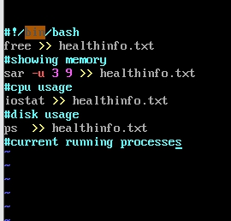

If you do not have executing right you would need to run this command also “chmod 777 file”. To run this script you will need to run this on the terminal “./file”. File being the name of what you want to run.



This shows the result of the script after it was run. To view this you would have to run this command “vim healthinfo.txt”. Healthinfo.txt being the name of the file the script is told to append the commands

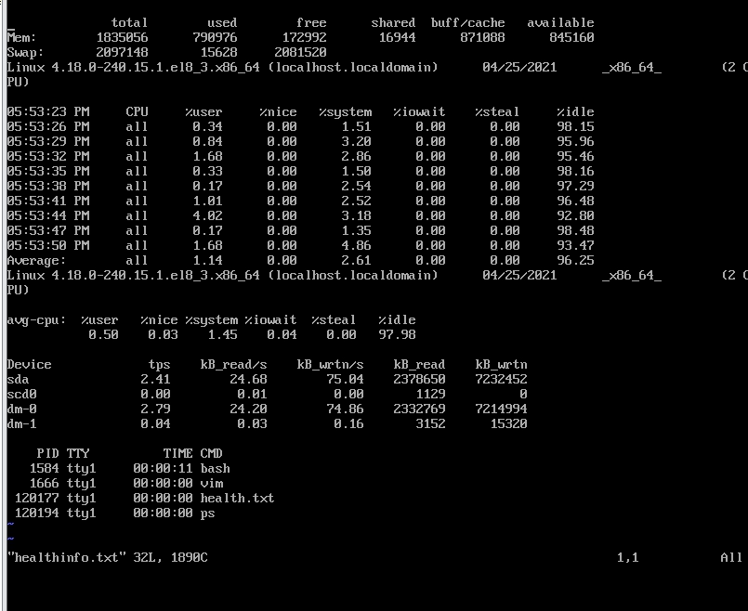

Sources:  
<https://www.maketecheasier.com/monitor-linux-performance-with-sysstat/#:~:text=Sysstat%20is%20a%20powerful%20logging,system%20performance%20and%20troubleshoot%20problems>.